**Week-4 Hands-On Assignment**

1. WebApi_Handson:

**First Web Api using .Net core:**

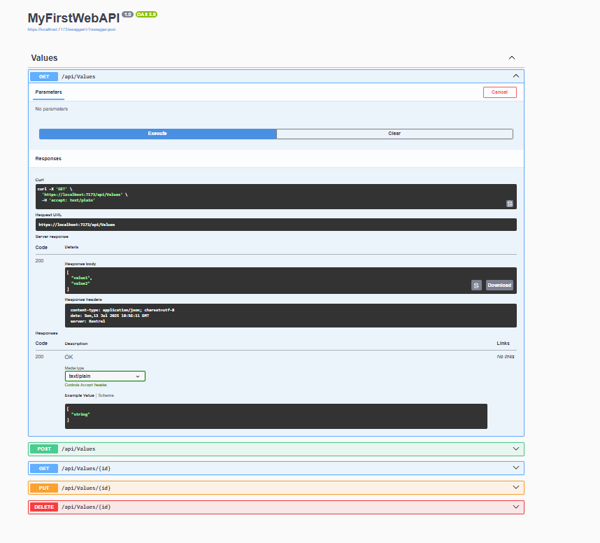

1. WebApi_Handson:

**Web Api using .Net core with Swagger:**

‘GET’ action verb method(Without the parameter)

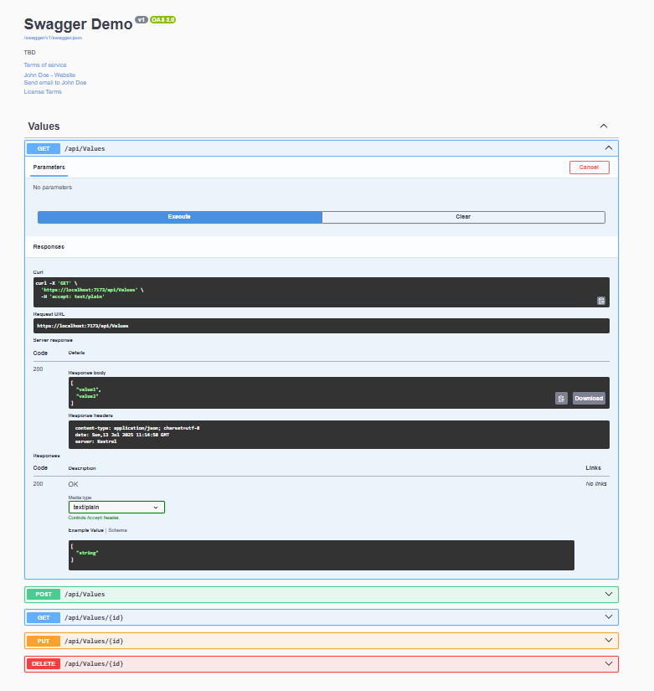

Postman:

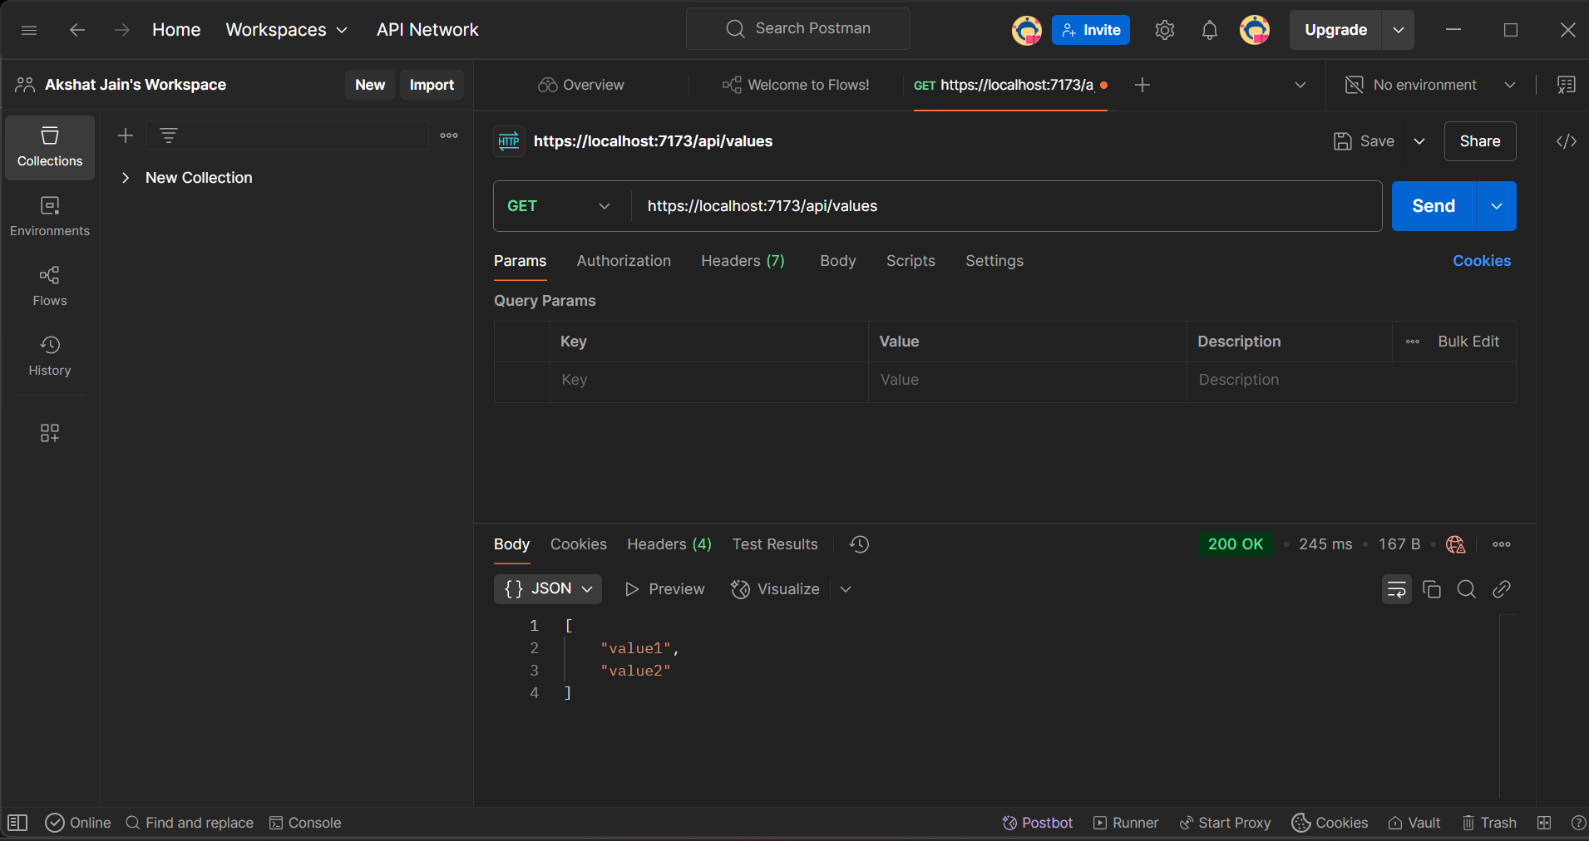

With changed route name (from values to emp):

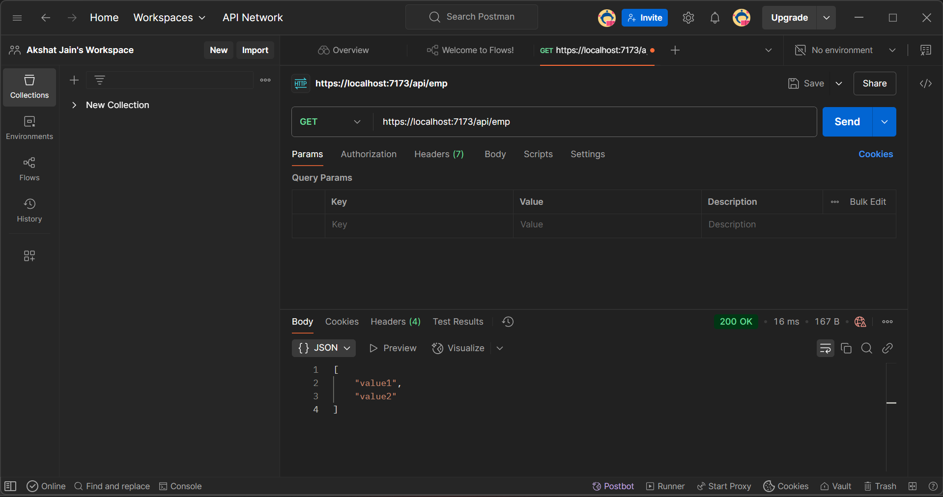

1. WebApi_Handson:

**Web Api using custom model class:**

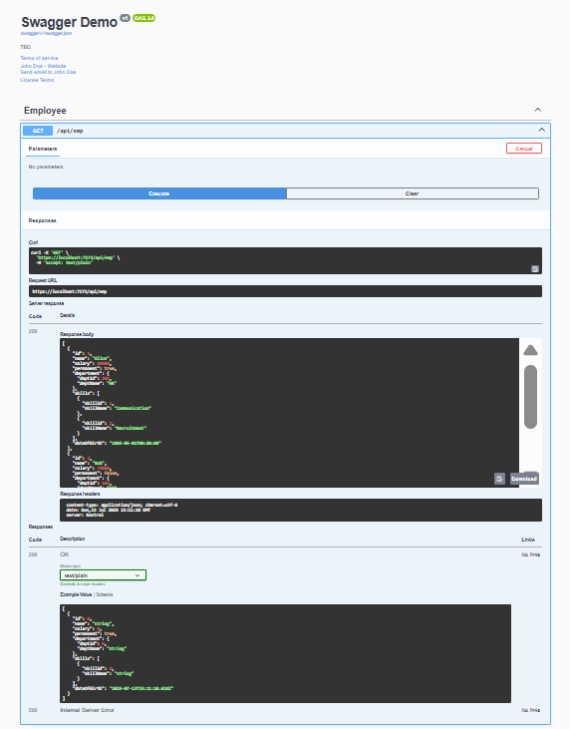

**Create a Custom action filter for Authorization:**

**Without Token:**

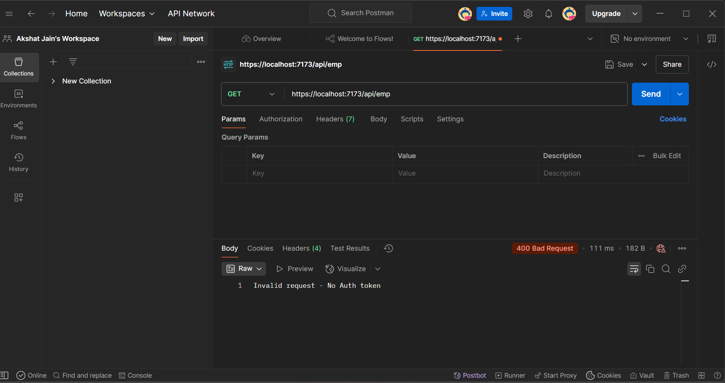

**With Token but no bearer:**

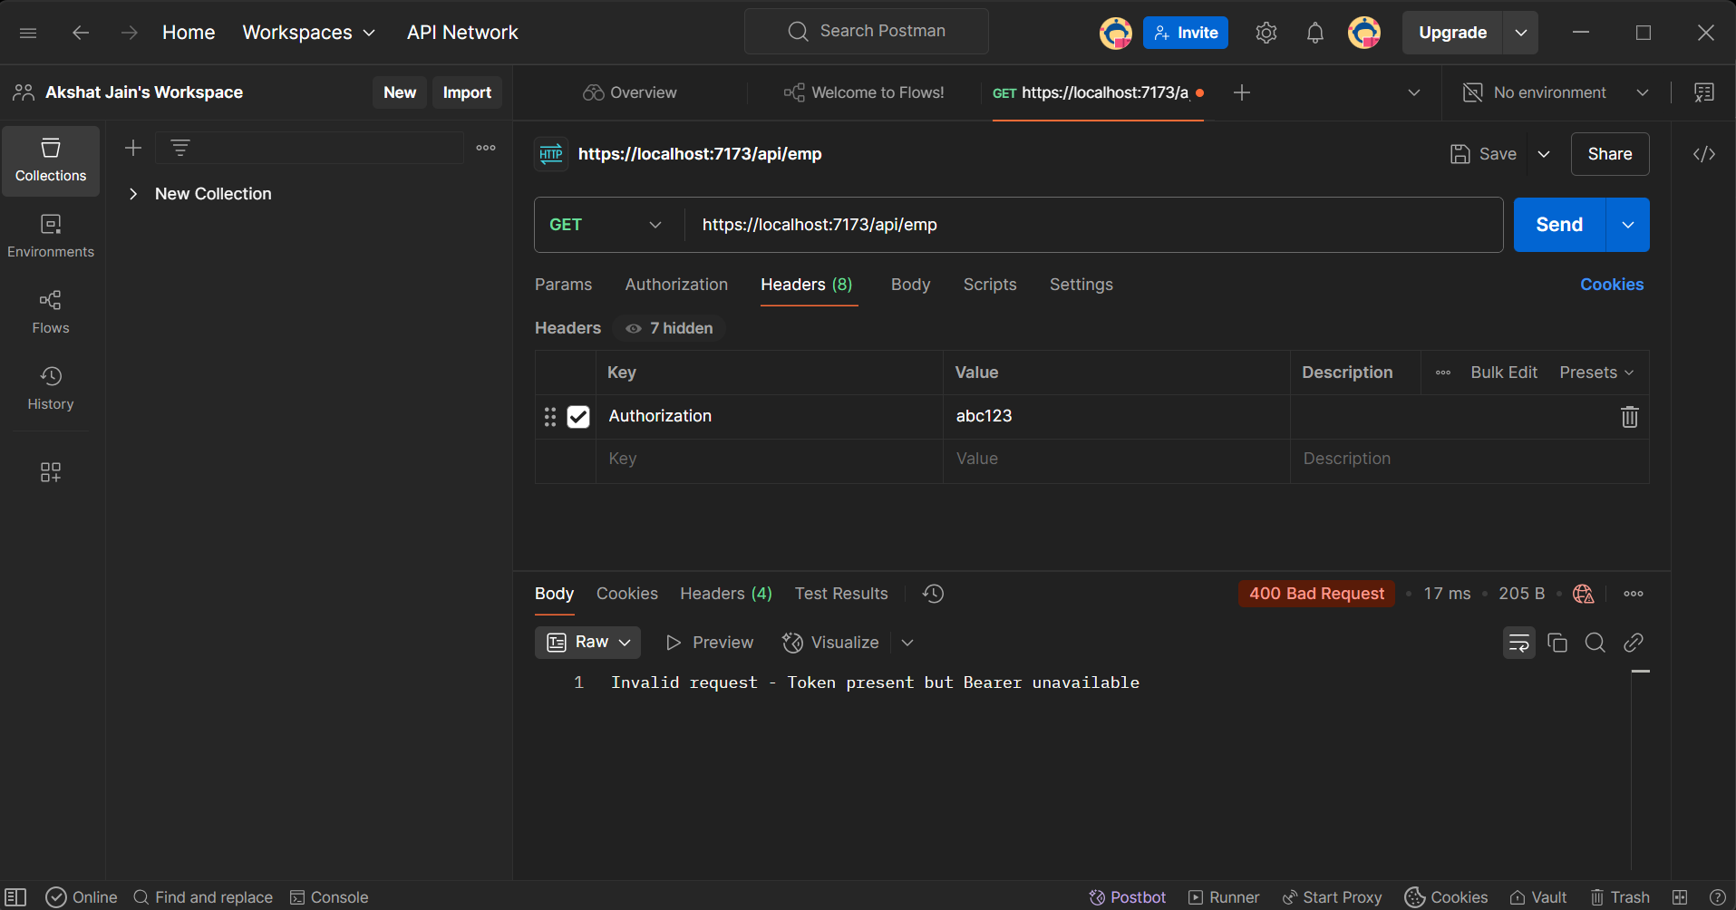

**With Token and Bearer:**

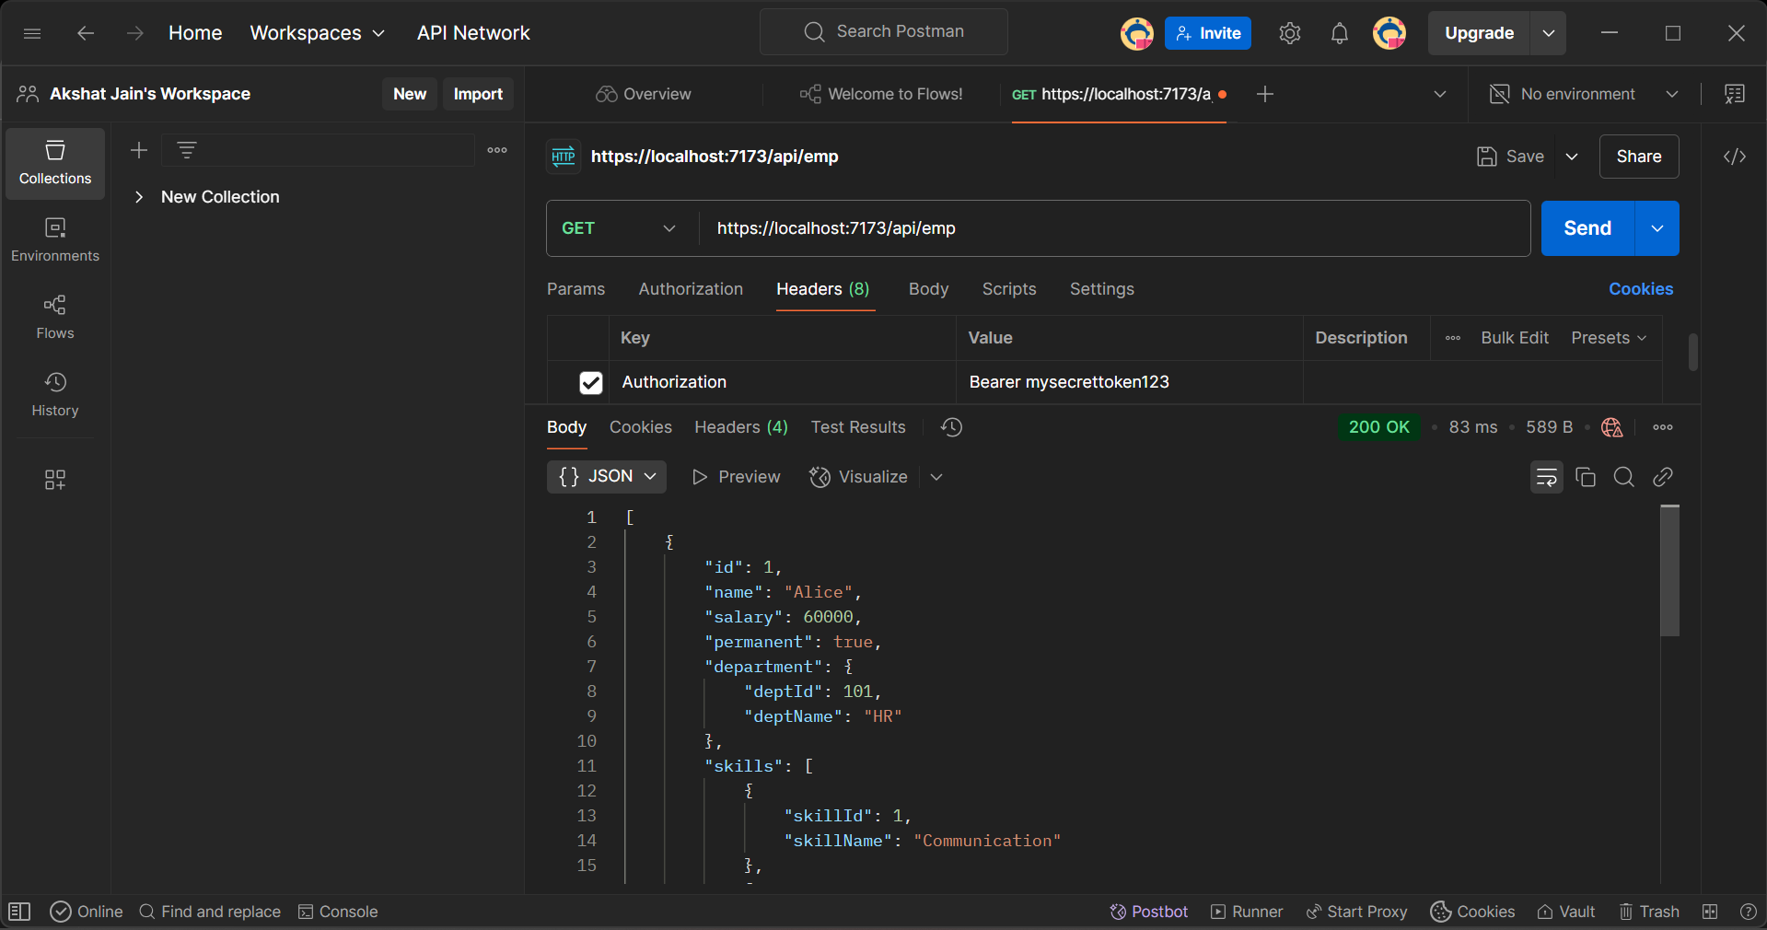

**Custom Exception filter:**

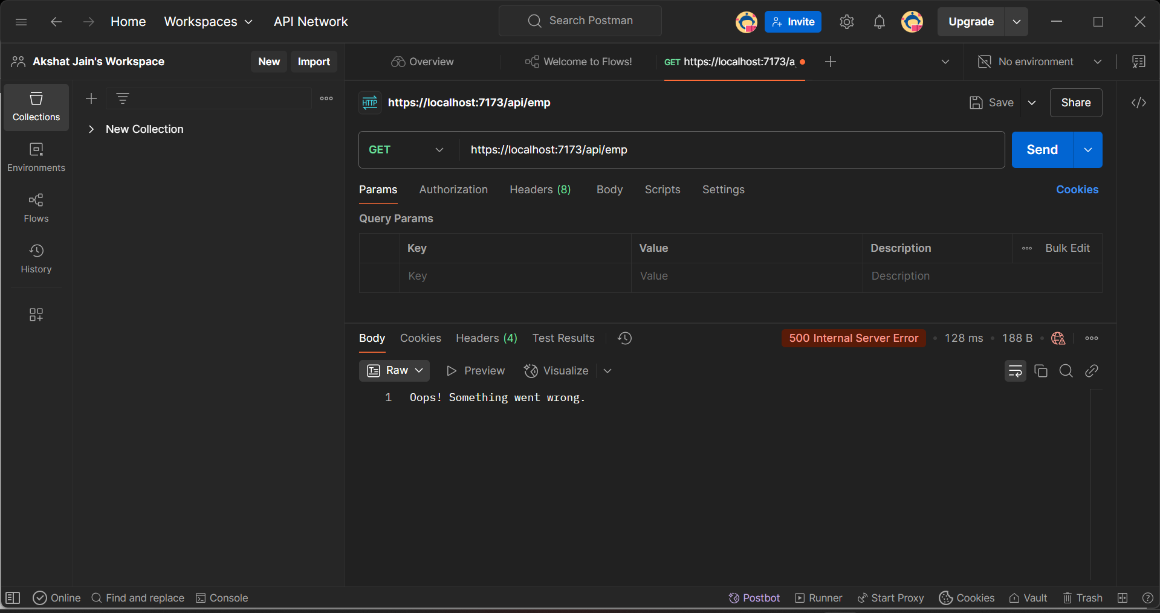

**Logs -> exceptions.txt:**

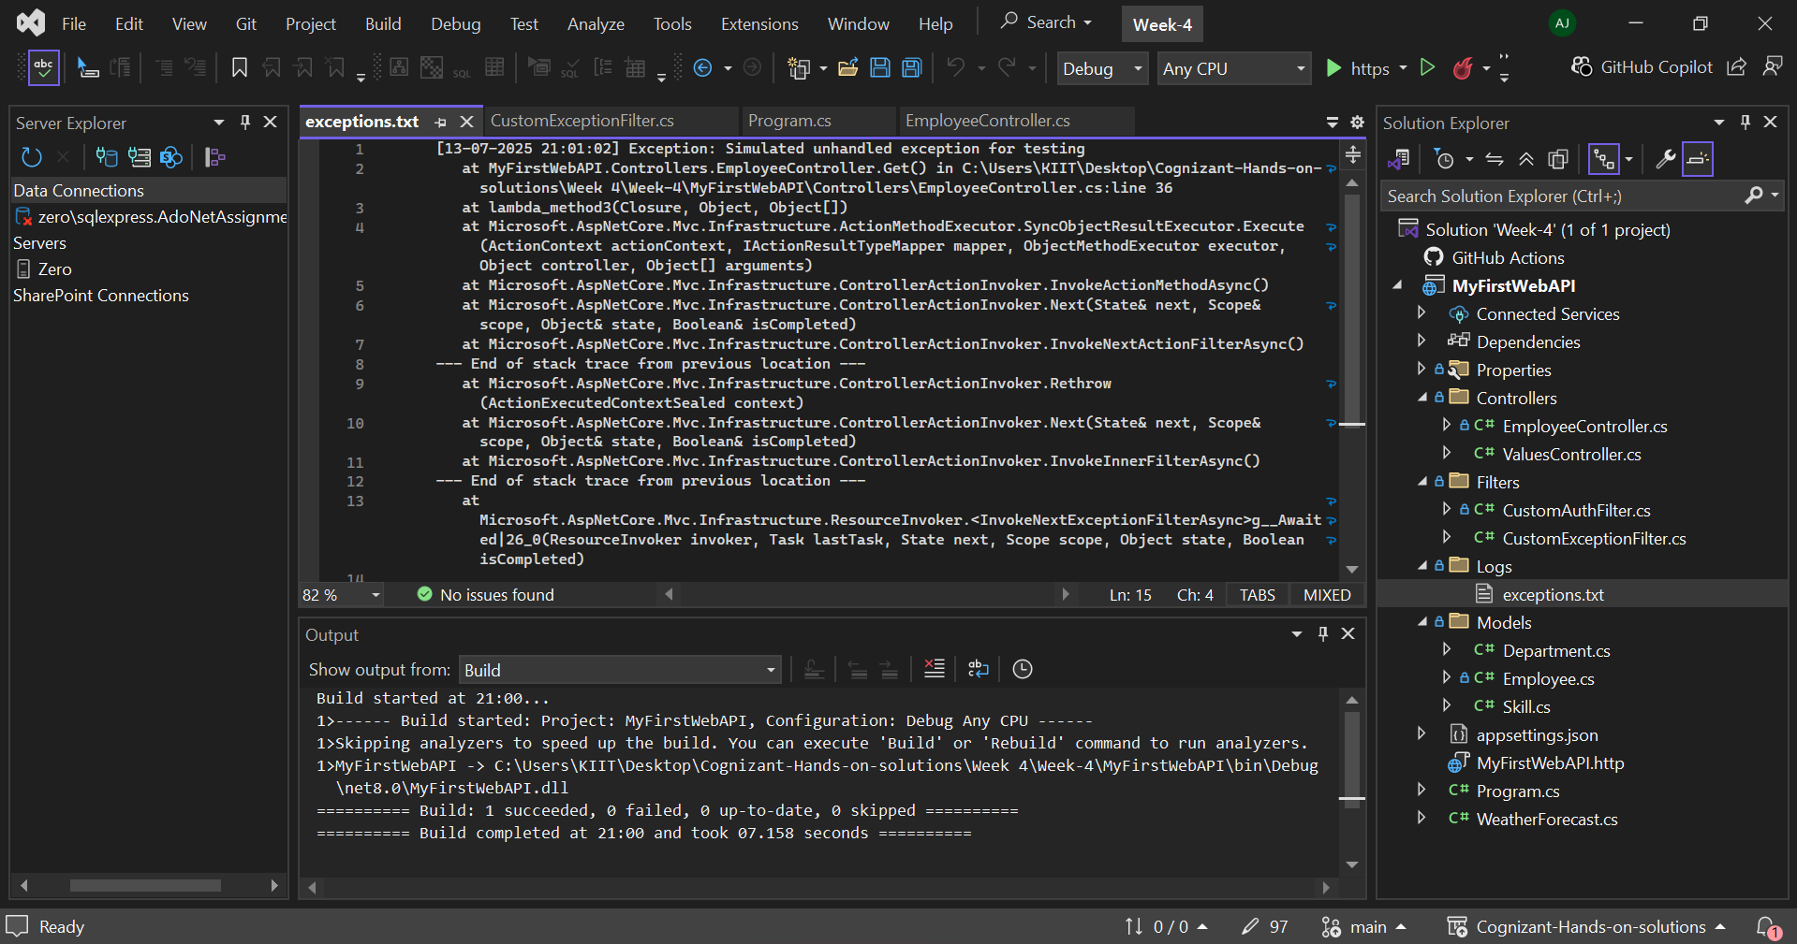

1. WebApi_Handson:

**Web Api CRUD operation:**

**When id = 1:**

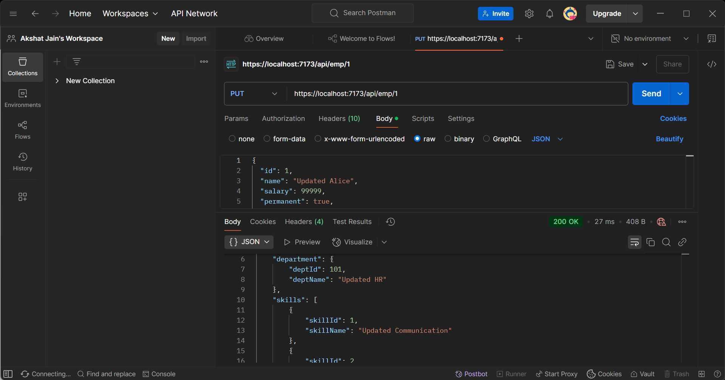

**When id = 0:**

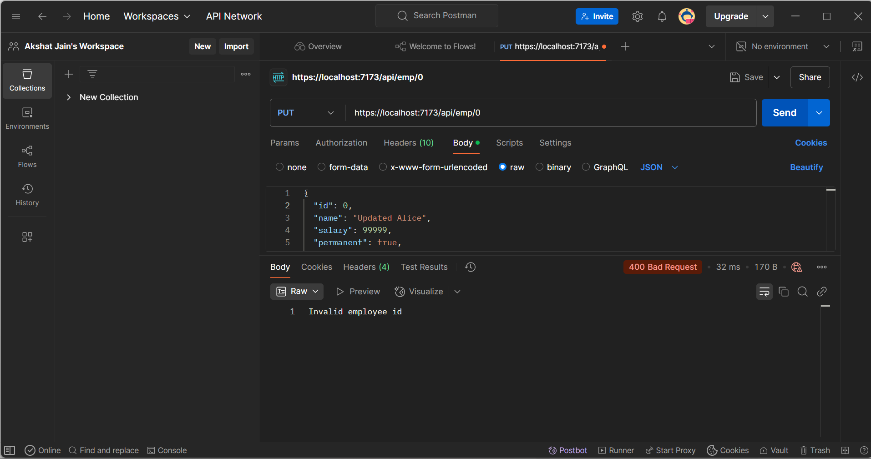

1. WebApi_Handson:

**JsonWebToken and used the JWT generated thru the AuthController to be used in POSTMAN request:**

**Token Generation:**

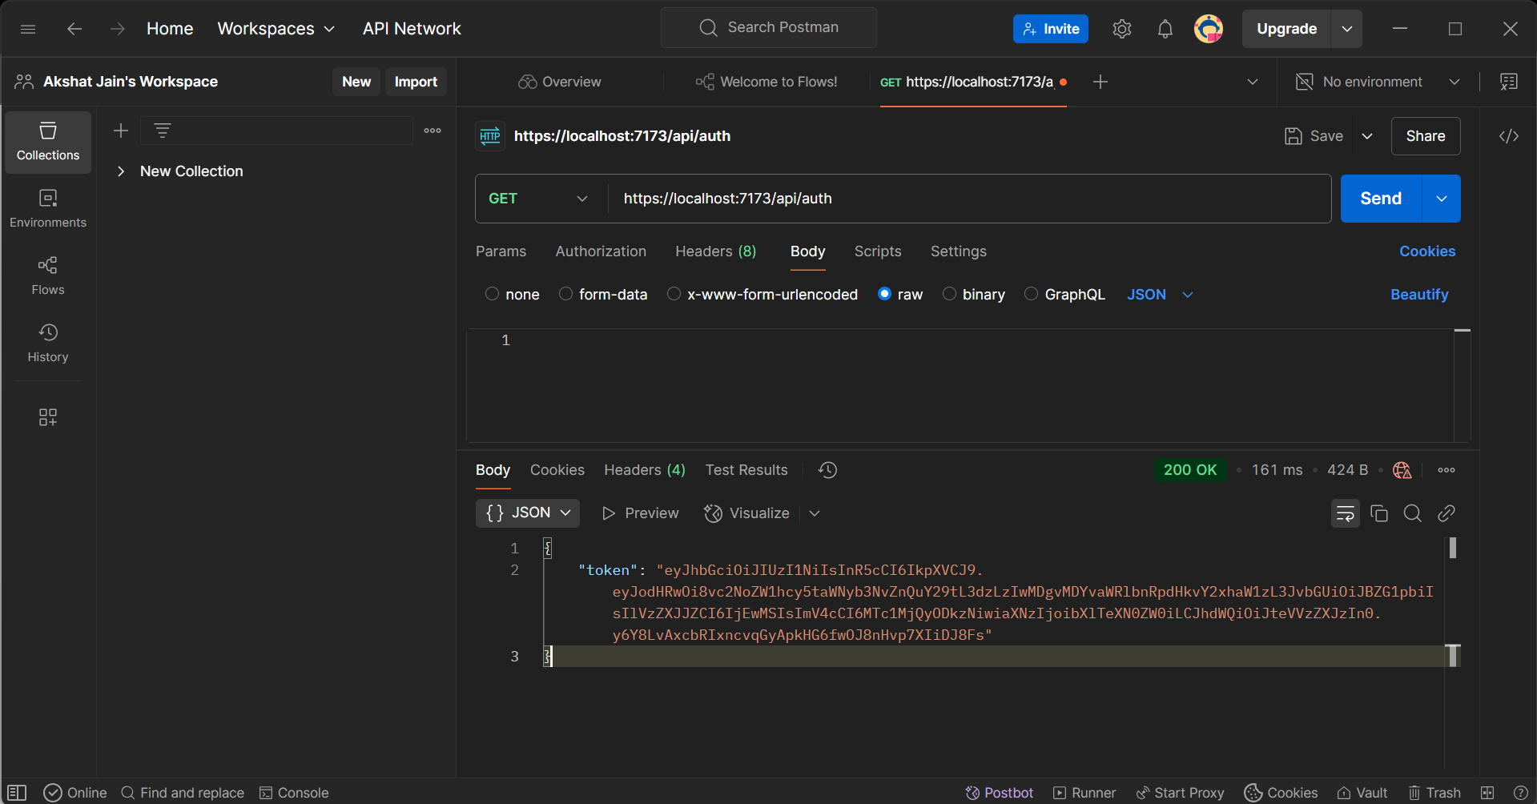

**Authorized Header with Token:**

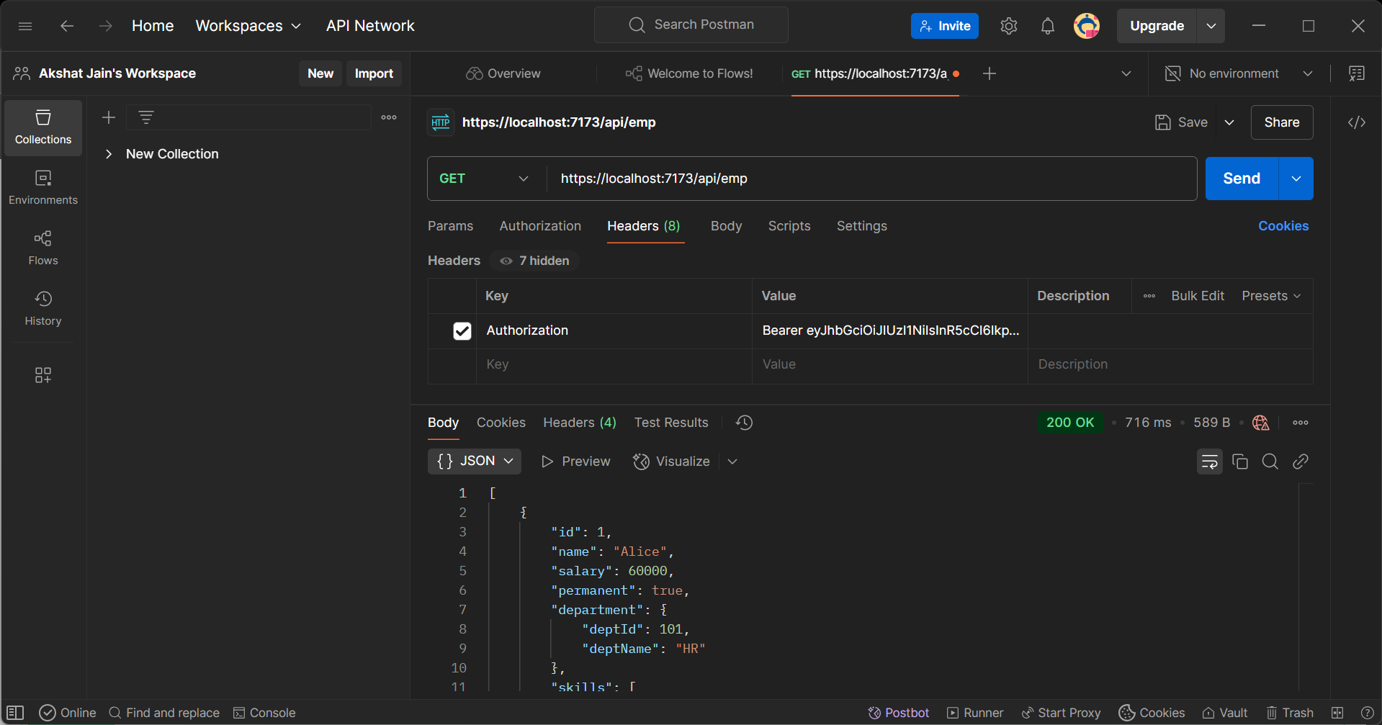

**Unauthorized Header:**

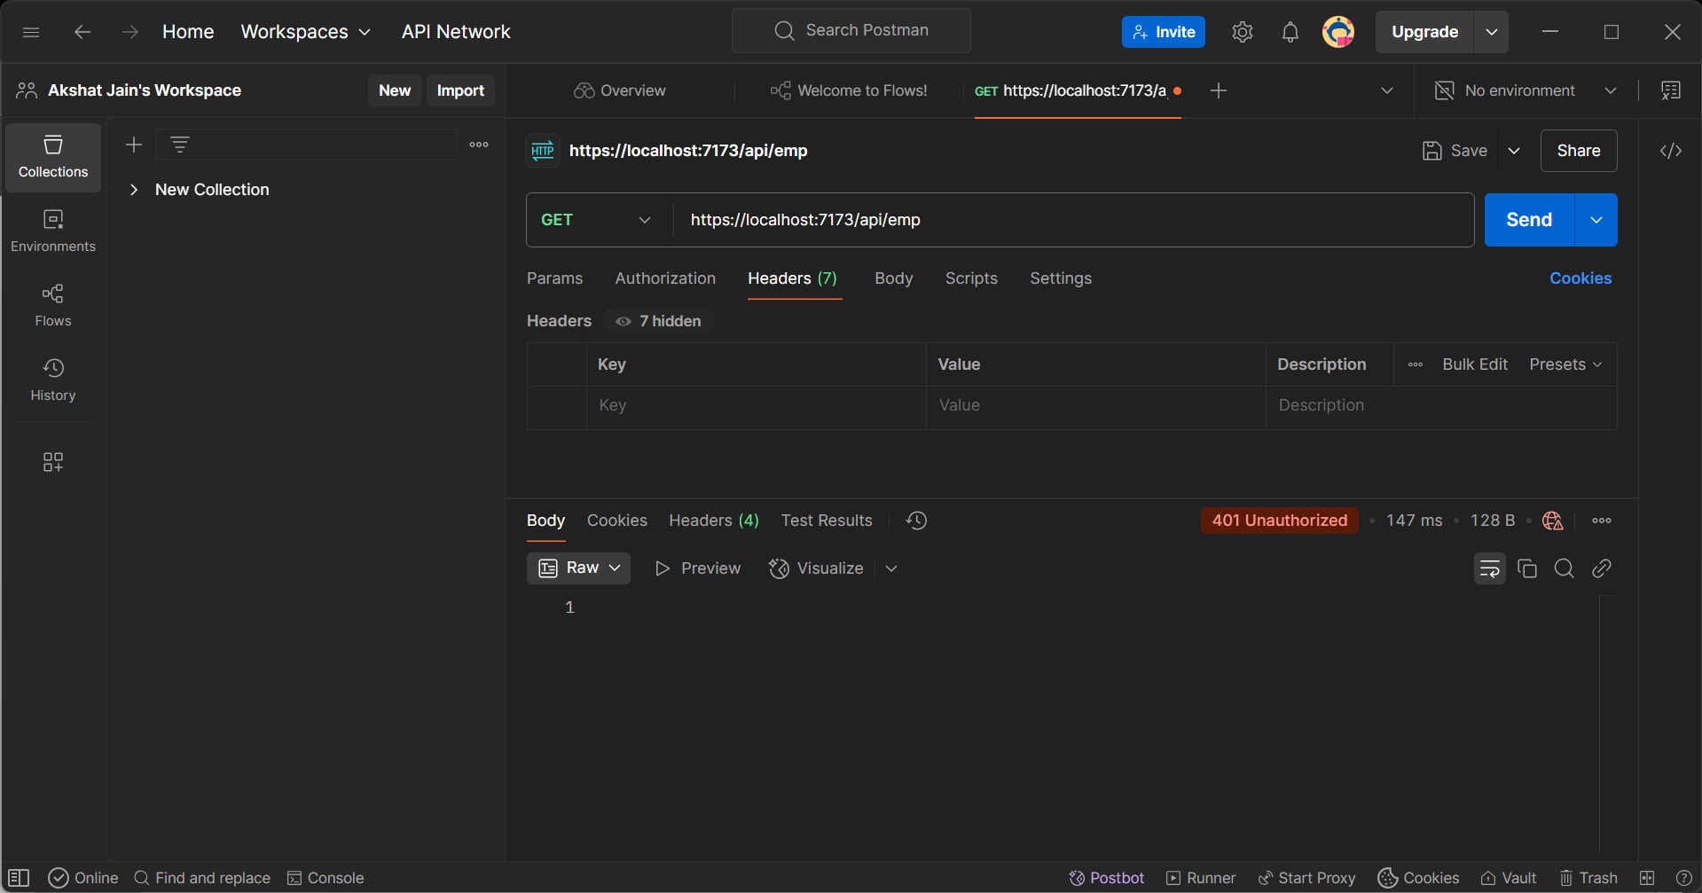

**Check for JWT expiration:**

